**SQL- Case Study**

“Richard’s Supply” is a company which deals with different food products. The company is associated with pool of suppliers. Every Supplier supplies different type of food products to Richard’s supply. This company also receives orders for the food products from various customers. Each order may have multiple products mentioned along with the quantity. The company is maintaining the database for 2 years.

Refer to the following Entity-Relationship diagram of the database.

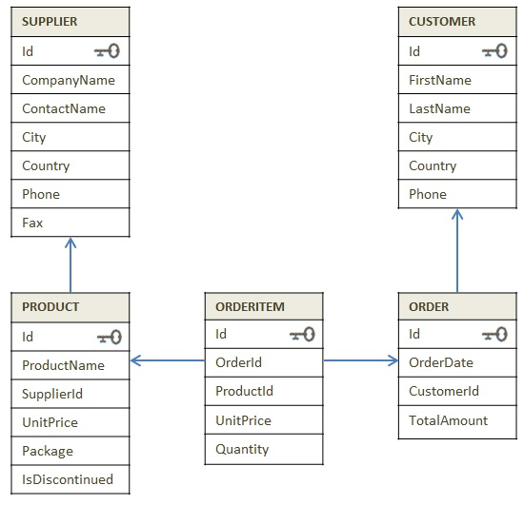

Diagram: E-R Diagram of Supply_chain database

Try to get insight of business through the dataset

**Instruction:** Execute the SQL files in the sequence given below.

1. 1_DDL_Case Study
2. 2_Data
3. 3_Data Constraints

**Section A --> Know your data Time: 45 min**

1. Read the data from all tables.
2. Find the country wise count of customers.
3. Display the products which are not discontinued.
4. Display the list of companies along with the product name that they are supplying.
5. Display customer's information who stays in 'Mexico'
6. Display the costliest item that is ordered by the customer.
7. Display supplier id who owns highest number of products.
8. Display month wise and year wise count of the orders placed.
9. Which country has maximum suppliers.
10. Which customers did not place any order.

**Use the Classicmodels Schema to solve the below problems.**

1. Using Classicmodels schema, Generate a report with all the order_number, status and the total sales. (orderdetails and orders)
2. Using Classicmodels schema, Generate a report with all the customers and their order details and products ordered. (customers,orders,orderdetails)
3. A Retail Store XYZ recently started up in the locality. After 3 months of running the store successfully, during analysis the store manager has observed that some products were unsold. The product was not sold even once to any customer. Retail store wants to release some offers on such products. Make a list of such products for the manager.(products and orderdetails)
4. A Shopping ecommerce site recently performed a detailed analysis of the data. It needs a report on the list of inactive customers. The company is planning on releasing offers to convert the inactive customers into active.Make a list of such names.(customers,orders)
5. Using Classicmodels schema, Generate a report with all the customers their ids, names and lifetime sales from the customer.(customer,payments)

**Use the Classicmodels Schema to solve the below problems on SubQueries.**

1. A Retail Store XYZ recently started up in the locality. After 3 months of running the store successfully, during analysis the store manager has observed that some products were unsold. The product was not sold even once to any customer. Retail store wants to release some offers on such products. Make a list of such products for the manager. .(products and orderdetails)
2. A Shopping ecommerce site recently performed a detailed analysis of the data. It needs a report on the list of inactive customers. The company is planning on releasing offers to convert the inactive customers into active.Make a list of such names. (customers,orders)
3. Generate a list of top 10 customers who have done maximum payments to the store. (customer and payments)
4. Generate a list of employees who had assisted the cutomers to place orders that were shipped within a span of 1 day of order getting placed.(employees, customers and orders)
5. Generate a list of product lines which are always ordered in bulk of more than 50 nos. (productline, products)

**Use the Classicmodels Schema to solve the below problems on WindowFunctions.**

1. For every customer, Get the details of all the orders placed by them and the date on which he/she had placed an order for the first time.
2. For the list of products in the products table, get the Quantities ordered in each order and most recent order Quantity.
3. Get the details of the employees, the details of the customers to whom they have assisted in placing orders, along with the current orderDate and the next order placed.
4. Generate a list of customers along with the dates on which they have made payments, and the previous payment dates. Filter out such customers who have done consecutive payments within a span of 30 days.
5. Write a Query to list the order dates and the cumulative distribution of the order Quantities for the every date.